**Blood Bank Database Management System**

IST 659

Fall 2023 Final Project

**Professor:**

Vincent Michael Plaza

**Members:**

Himanshu Hedge

Soundarya Ravi

Subhiksha Murugesan

Rishi Manohar

Nagul Pandian

Contents

1.Proposal for the Implementation of a Blood Bank Management Database 3

1.1. Introduction 3

1.2.Article Review 3

1.3.Project Description 4

1.4.Solution Architecture 5

**1.5**. Timelines 6

1.6.Expected Outcome 7

**2.Technical Solution** 7

2.1. Backend SQL Scripts 7

2.1.1 **Table count:** A total of 8 Fact and 12 Dim Tables have been created. 8

2.2.2. **Stored Procedures:** 8

2.2.3. **Triggers:** 9

2.2.4. **Views:** 9

2.2 Conceptual and Logical Diagram 9

2.2.1. **Conceptual Diagram** 10

2.2.2. **Logical Diagram** 11

2.2 Frontend Power BI Dashboard 11

3.Team Log 15

# 1.Proposal for the Implementation of a Blood Bank Management Database

## Introduction

Blood banks play a vital role in healthcare systems by ensuring a steady supply of safe and compatible blood products for various medical procedures, including surgeries, trauma care, and treatment of chronic illnesses. Efficient blood bank management is crucial to meet the growing demand for blood and blood products while maintaining the highest standards of safety and traceability.This proposal presents a detailed plan for the development and implementation of a sophisticated blood bank management database. The main objective of this project is to significantly enhance the efficiency and effectiveness of blood bank operations by streamlining inventory monitoring, expediting transfusions, and establishing a highly reliable database system to comprehensively map and track the flow of blood and related resources within the system.

## 1.2.Article Review

Blood transfusion is an essential medical procedure that plays a critical role in saving lives across a range of medical scenarios, such as surgeries, cancer treatments, and urgent medical crises. Nevertheless, the availability and ease of access to blood products continue to pose considerable difficulties in numerous regions globally. The conventional paper-based blood bank management system has proven insufficient in keeping pace with the demands of contemporary healthcare. In recent times, the academic community has introduced several approaches pertaining to blood bank database systems. This section provides an overview of some pertinent methods:

1.2.1. Enhancing Blood Donor Information and Management System via Technopedia

In their work, Priya et al[1] has introduced an Android mobile application incorporated with GIS technology to establish a productive, well-organized, and secure Information Management System. The proposed solution is adept at identifying fraudulent donors and preventing the misuse of information by application users. Furthermore, it incorporates quality control measures at various stages, a crucial aspect for ensuring patient safety.

1.2.2. Investigation into Blood Bank Management Systems

Teena et al [2] has designed an efficient information management system that maintains comprehensive records of donors and patients. This system features a security layer, ensuring that only authorized Blood bank personnel can access and update records through a secure login mechanism employing confidential passwords.

1.2.3. Real-Time RFID-Based Blood Bank Management for Enhanced Efficiency

Pramodini et al[3] has developed a database system with the primary goal of minimizing human errors, particularly those that may occur during blood transfusions. Their innovation involves the implementation of a Blood bank Database Management System (DBMS) based on Radio-Frequency Identification (RFID) technology, aimed at significantly reducing these error rates.

## 1.3.Project Description

The proposed project aims to develop and implement a comprehensive Blood Bank Management Database to significantly enhance the efficiency and effectiveness of blood bank operations.This database will serve as a centralized system to streamline inventory monitoring, expedite transfusions, and establish a highly reliable database system to comprehensively map and track the flow of blood and related resources within the blood bank. The forthcoming database will feature a user-friendly UI/UX front-end specifically tailored for a diverse range of stakeholders.

The stakeholders involved are as follows:

1. Blood Centers

The DBMS tool aids in overseeing blood inventory across multiple centers in response to hospital and patient demand, as well as donation requests. This user-friendly interface empowers blood facilities to monitor the journey of collected blood from collection through labeling, testing, and storage. Additionally, it facilitates the analysis and modification of donor profiles, blood types, diseases, and other pertinent information, enhancing their ability to efficiently categorize donors for further analysis and donation efforts.

1. Hospitals

The DBMS tool enables hospitals and patients to request blood, specifying the cause, blood type, and quantity needed, among other parameters. They can also use it to monitor the progress of their applications.In case of a medical emergency, this tool enables swift, accurate, and immediate identification of accessible blood products and the closest suitable blood centers capable of supplying blood. This is achieved through the retrieval of incident data, which is then cross-referenced with inventory records and blood center databases.

1. Blood Donors

The service enables donor level visibility: Donor profilesand informationn,camp information for donors to sign up for blood donation programs and to subscribe to updates about their donations.

The aim is to create an intuitive and accessible platform that allows seamless interaction for

these key participants.This inclusivity will enhance overall usability and productivity, ultimately leading to more effective management of blood bank operations.

## 1.4.Solution Architecture

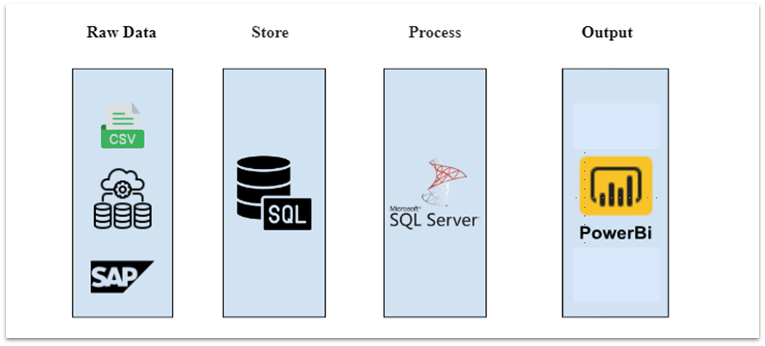

The technical implementation can be divided into 4 layers : Raw data ingestion, Storage, Processing and Output.

Raw Data ingestion involves the collection of data from different sources. The data is then ingested into a SQL DB, which acts as the storage layer. This data is then processed according to business logic and requirements using MS SQL Server and then fed into the Output( Visualization) layer, where it is consumed by the users as an interactive dashboard/web app.

## **1.5**. Timelines

|  |  |  |  |  |  |  |  |  |  |
| --- | --- | --- | --- | --- | --- | --- | --- | --- | --- |
| **Owner** | **Topic** | **9 Oct 2023** | **16 Oct 2023** | **23 Oct 2023** | **3 Nov 2023** | **12 Nov 2023** | **29 Nov 2023** | **5 Dec 2023** | **10 Dec 2023** |
| Everyone | All text book Videos + Concepts |  |  |  |  |  |  |  |  |
| Rishi + Nagul + Subhiksha | Front-end mock-up (Figma/power apps) |  |  |  |  |  |  |  |  |
| Everyone | Front-end mock-up validation |  |  |  |  |  |  |  |  |
| Himanshu + Soundarya+ Subhiksha | Backend Table Design - Brainstorming |  |  |  |  |  |  |  |  |
| Soundarya + Subhiksha | Backend Data Model Diagram (Draw.io) |  |  |  |  |  |  |  |  |
| Soundarya + Himanshu | Building SQL DB Table scripts |  |  |  |  |  |  |  |  |
| Rishi + Nagul + Subhiksha | Front-end Powerapps tool |  |  |  |  |  |  |  |  |
| Everyone | User Testing + Validation |  |  |  |  |  |  |  |  |
| Everyone | Documentation + PPT |  |  |  |  |  |  |  |  |
| Everyone | Cross Training |  |  |  |  |  |  |  |  |

## 1.6.Expected Outcome

The implementation of the Blood Bank Management Database is anticipated to yield a range of significant outcomes and benefits, contributing to the enhancement of blood bank operations and overall healthcare services:

1. Enhanced Decision Making Capability: With streamlined inventory monitoring and a user-friendly front-end interface, the database will lead to improved operational efficiency within blood banks. This means quicker access to blood products, reduced wait times for patients, and optimized resource allocation. A highly intuitive user interface allows for quicker and more efficient strategic decision-making and planning at the organizational levels by anticipating inventory shortage and supply chain constraints well in advance.

# **2.Technical Solution**

## 2.1. Backend SQL Scripts

**Contents of SQL Script:**

1) Delete Foreign Keys

2) Drop Tables

3) Create Tables

4) Add CONSTRAINTS

5) Add Triggers

6) Insert Operations

5) Stored Procedures

6) Views

### 2.1.1 **Table count:** A total of 8 Fact and 12 Dim Tables have been created.

|  |  |
| --- | --- |
| **TableName** | **RowCounts** |
| dim_donor | 50 |
| dim_hospital | 10 |
| dim_camp | 20 |
| dim_blood_collection | 50 |
| dim_blood_donation_drive | 50 |
| dim_recipient | 30 |
| dim_staff | 20 |
| dim_blood_disease | 50 |
| dim_inventory | 20 |
| dim_component | 5 |
| dim_hospital_staff_details | 50 |
| fact_blood_donation_drive | 50 |
| fact_blood_pre_process_storage | 80 |
| fact_processing_disease_test | 40 |
| fact_processing_centrifuge | 43 |
| fact_storage_inventory | 41 |
| fact_blood_requests | 50 |
| fact_hospital_requests | 50 |
| fact_patient_to_hospital | 50 |
| sysdiagrams | 0 |

### 2.2.2. **Stored Procedures:**

3 Stored procedures created to ensure seamless insertion of data into Fact Tables.

|  |  |
| --- | --- |
| **S.No.** | **Stored Procedure** |
| 1 | InsertBloodRequest |
| 2 | InsertPatientToHospital |
| 3 | InsertBloodDonationDrive |

### 2.2.3. **Triggers:**

7 Triggers created to ensure integrity of post Insert/Update Operations

|  |  |
| --- | --- |
| **No.** | **Triggers** |
| 1 | trg_update_dim_blood_donation_camp_date |
| 2 | trg_update_fact_blood_donation_drive_camp_date |
| 3 | trg_update_fact_blood_pre_process_storage_date |
| 4 | trg_delete_rows_where_blood_bag_has_disease_in_centrifuge |
| 5 | trg_delete_rows_where_blood_bag_has_disease_in_inventory |
| 6 | trg_update_fact_processing_centrifuge_process_date |
| 7 | trg_update_fact_storage_inventory_storage_date |

### 2.2.4. **Views:**

2 Views created for specific business purposes – they are a combination of Fact and Dim Tables.

|  |  |
| --- | --- |
| S.No. | View |
| 1 | vw_blood_donation_drive_details |
| 2 | vw_blood_requests_from_hospitals |

## 2.2 Conceptual and Logical Diagram

### 2.2.1. **Conceptual Diagram**

### 2.2.2. **Logical Diagram**

## 2.2 Frontend Power BI Dashboard

The process flow and the views in the Dashboard are as follows:

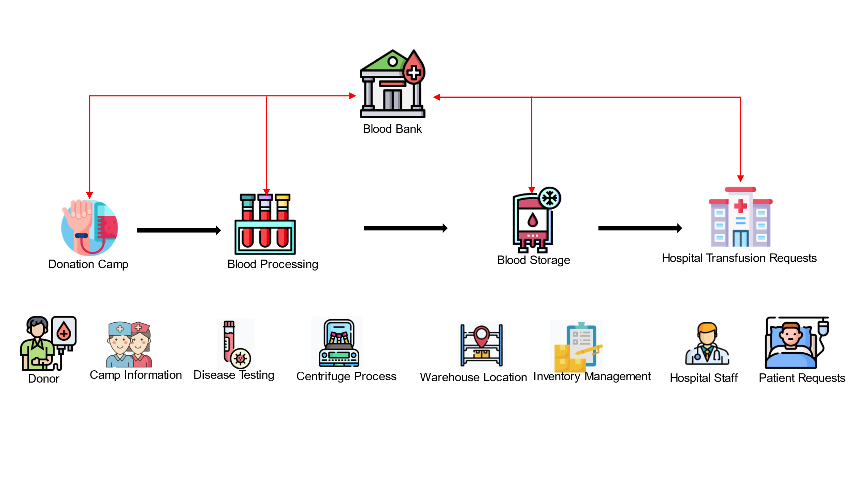

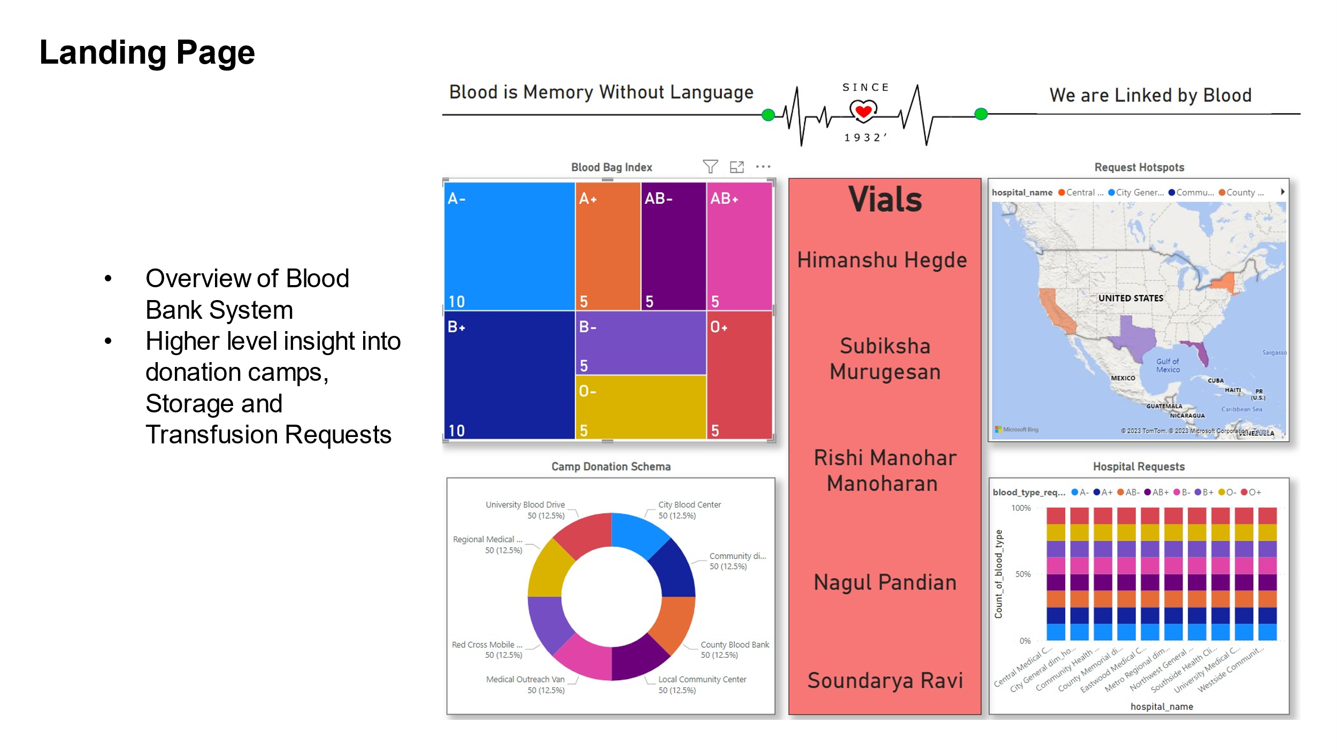

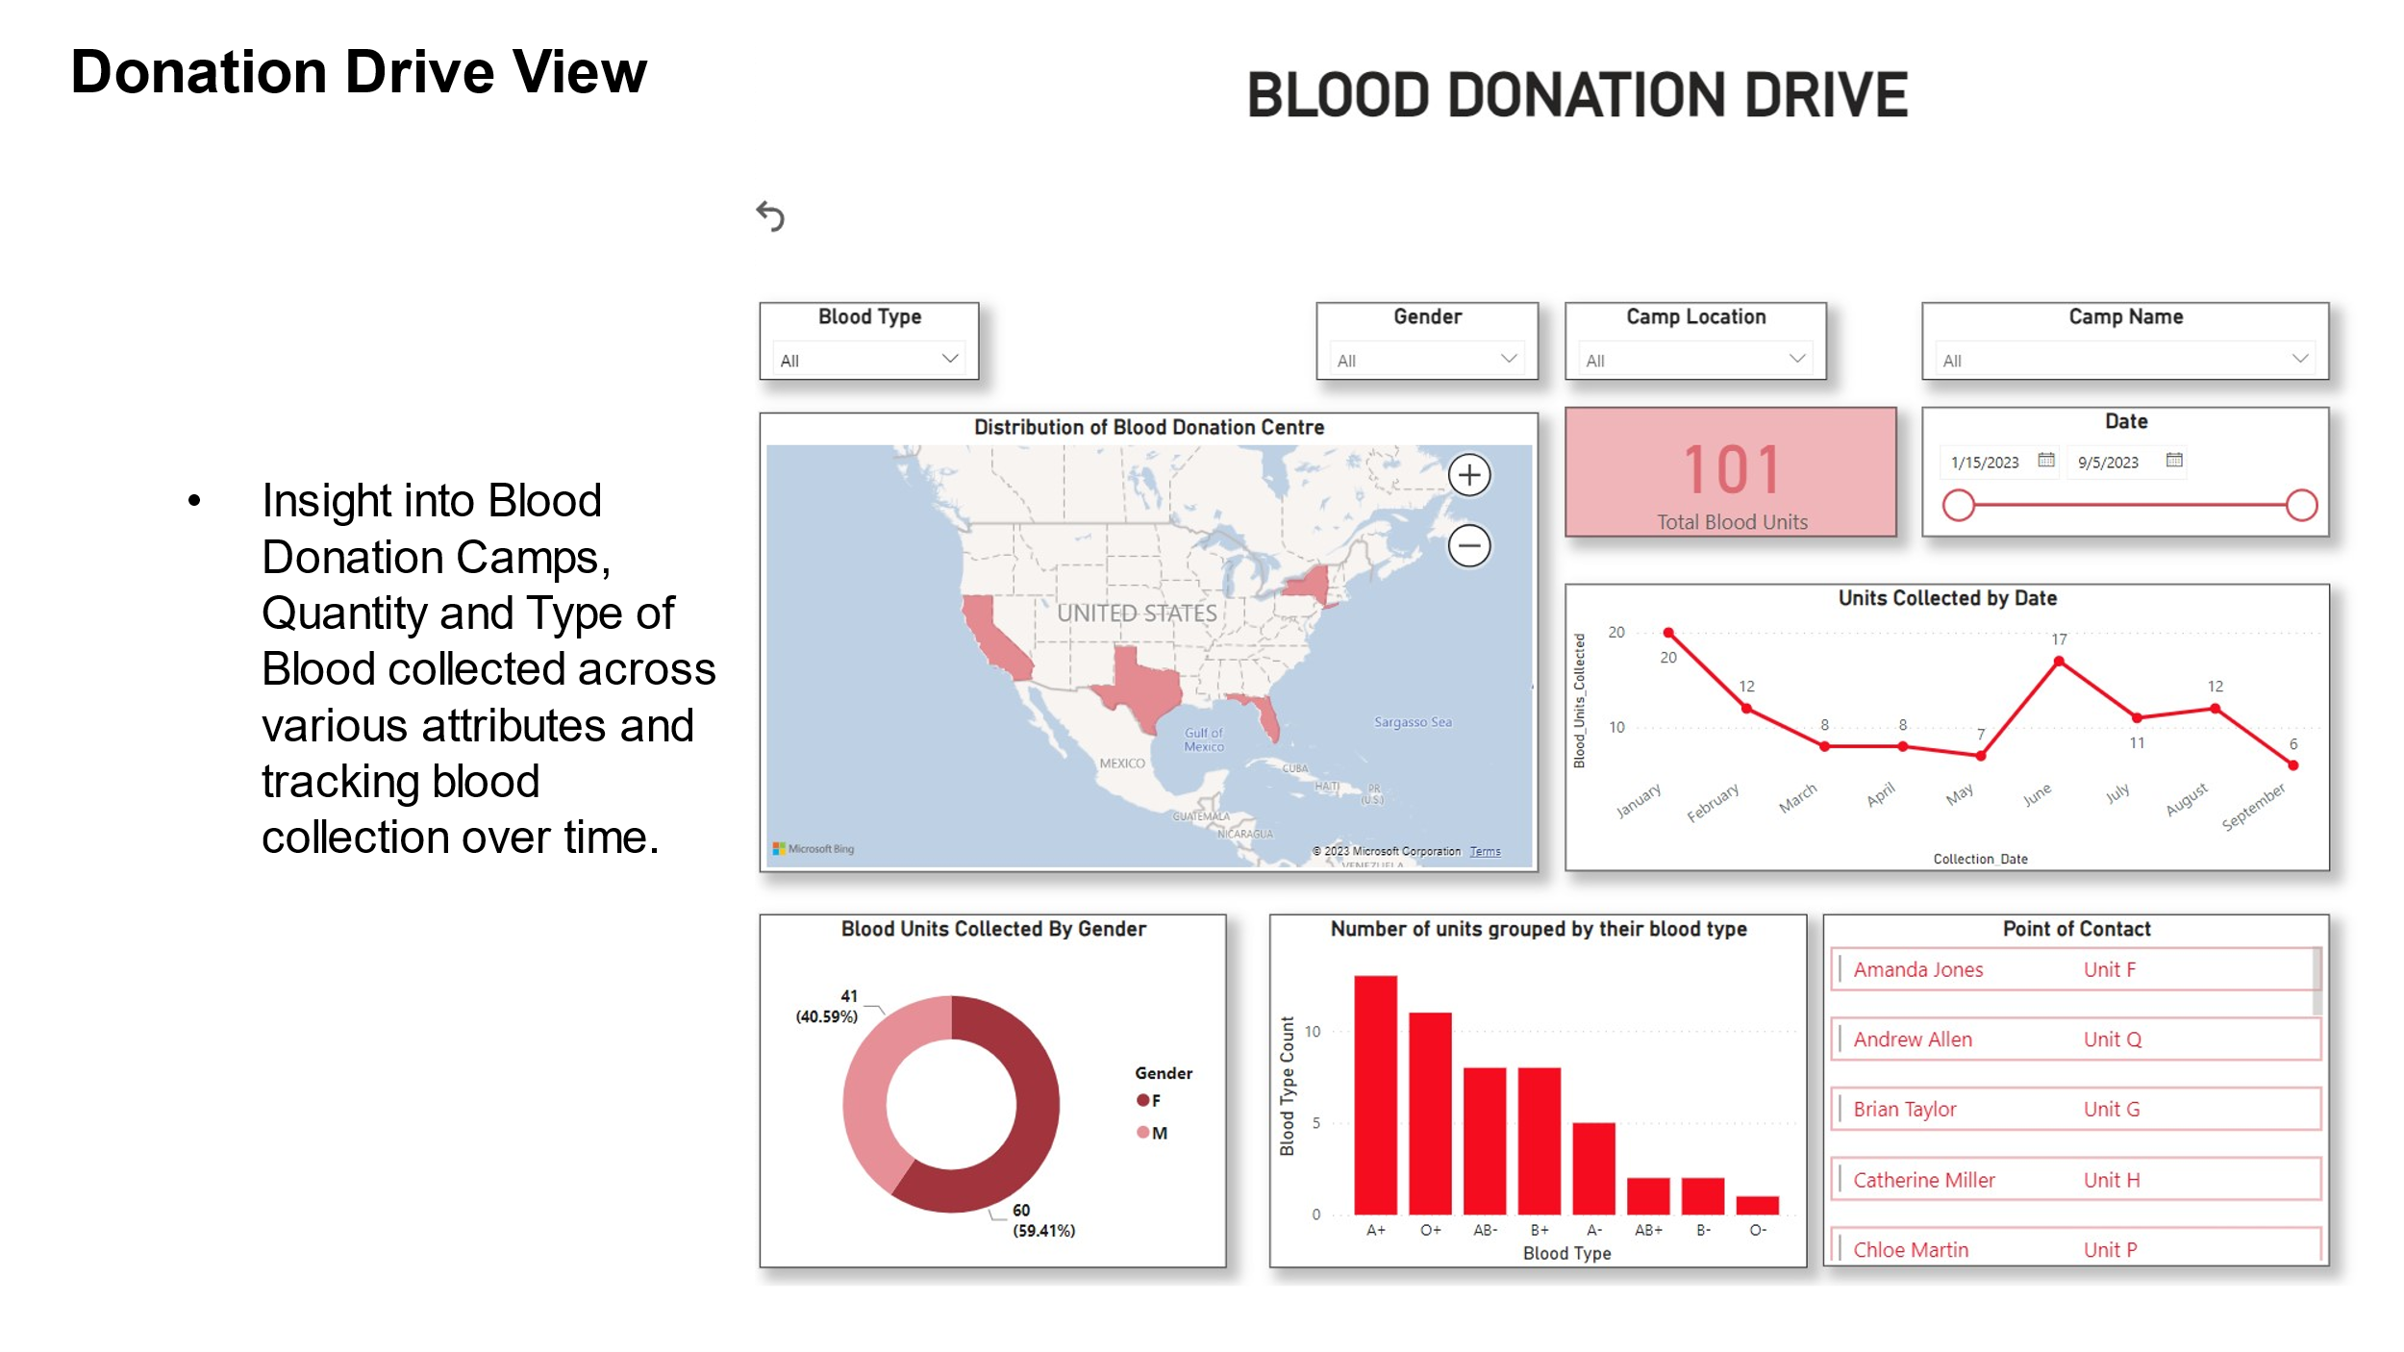

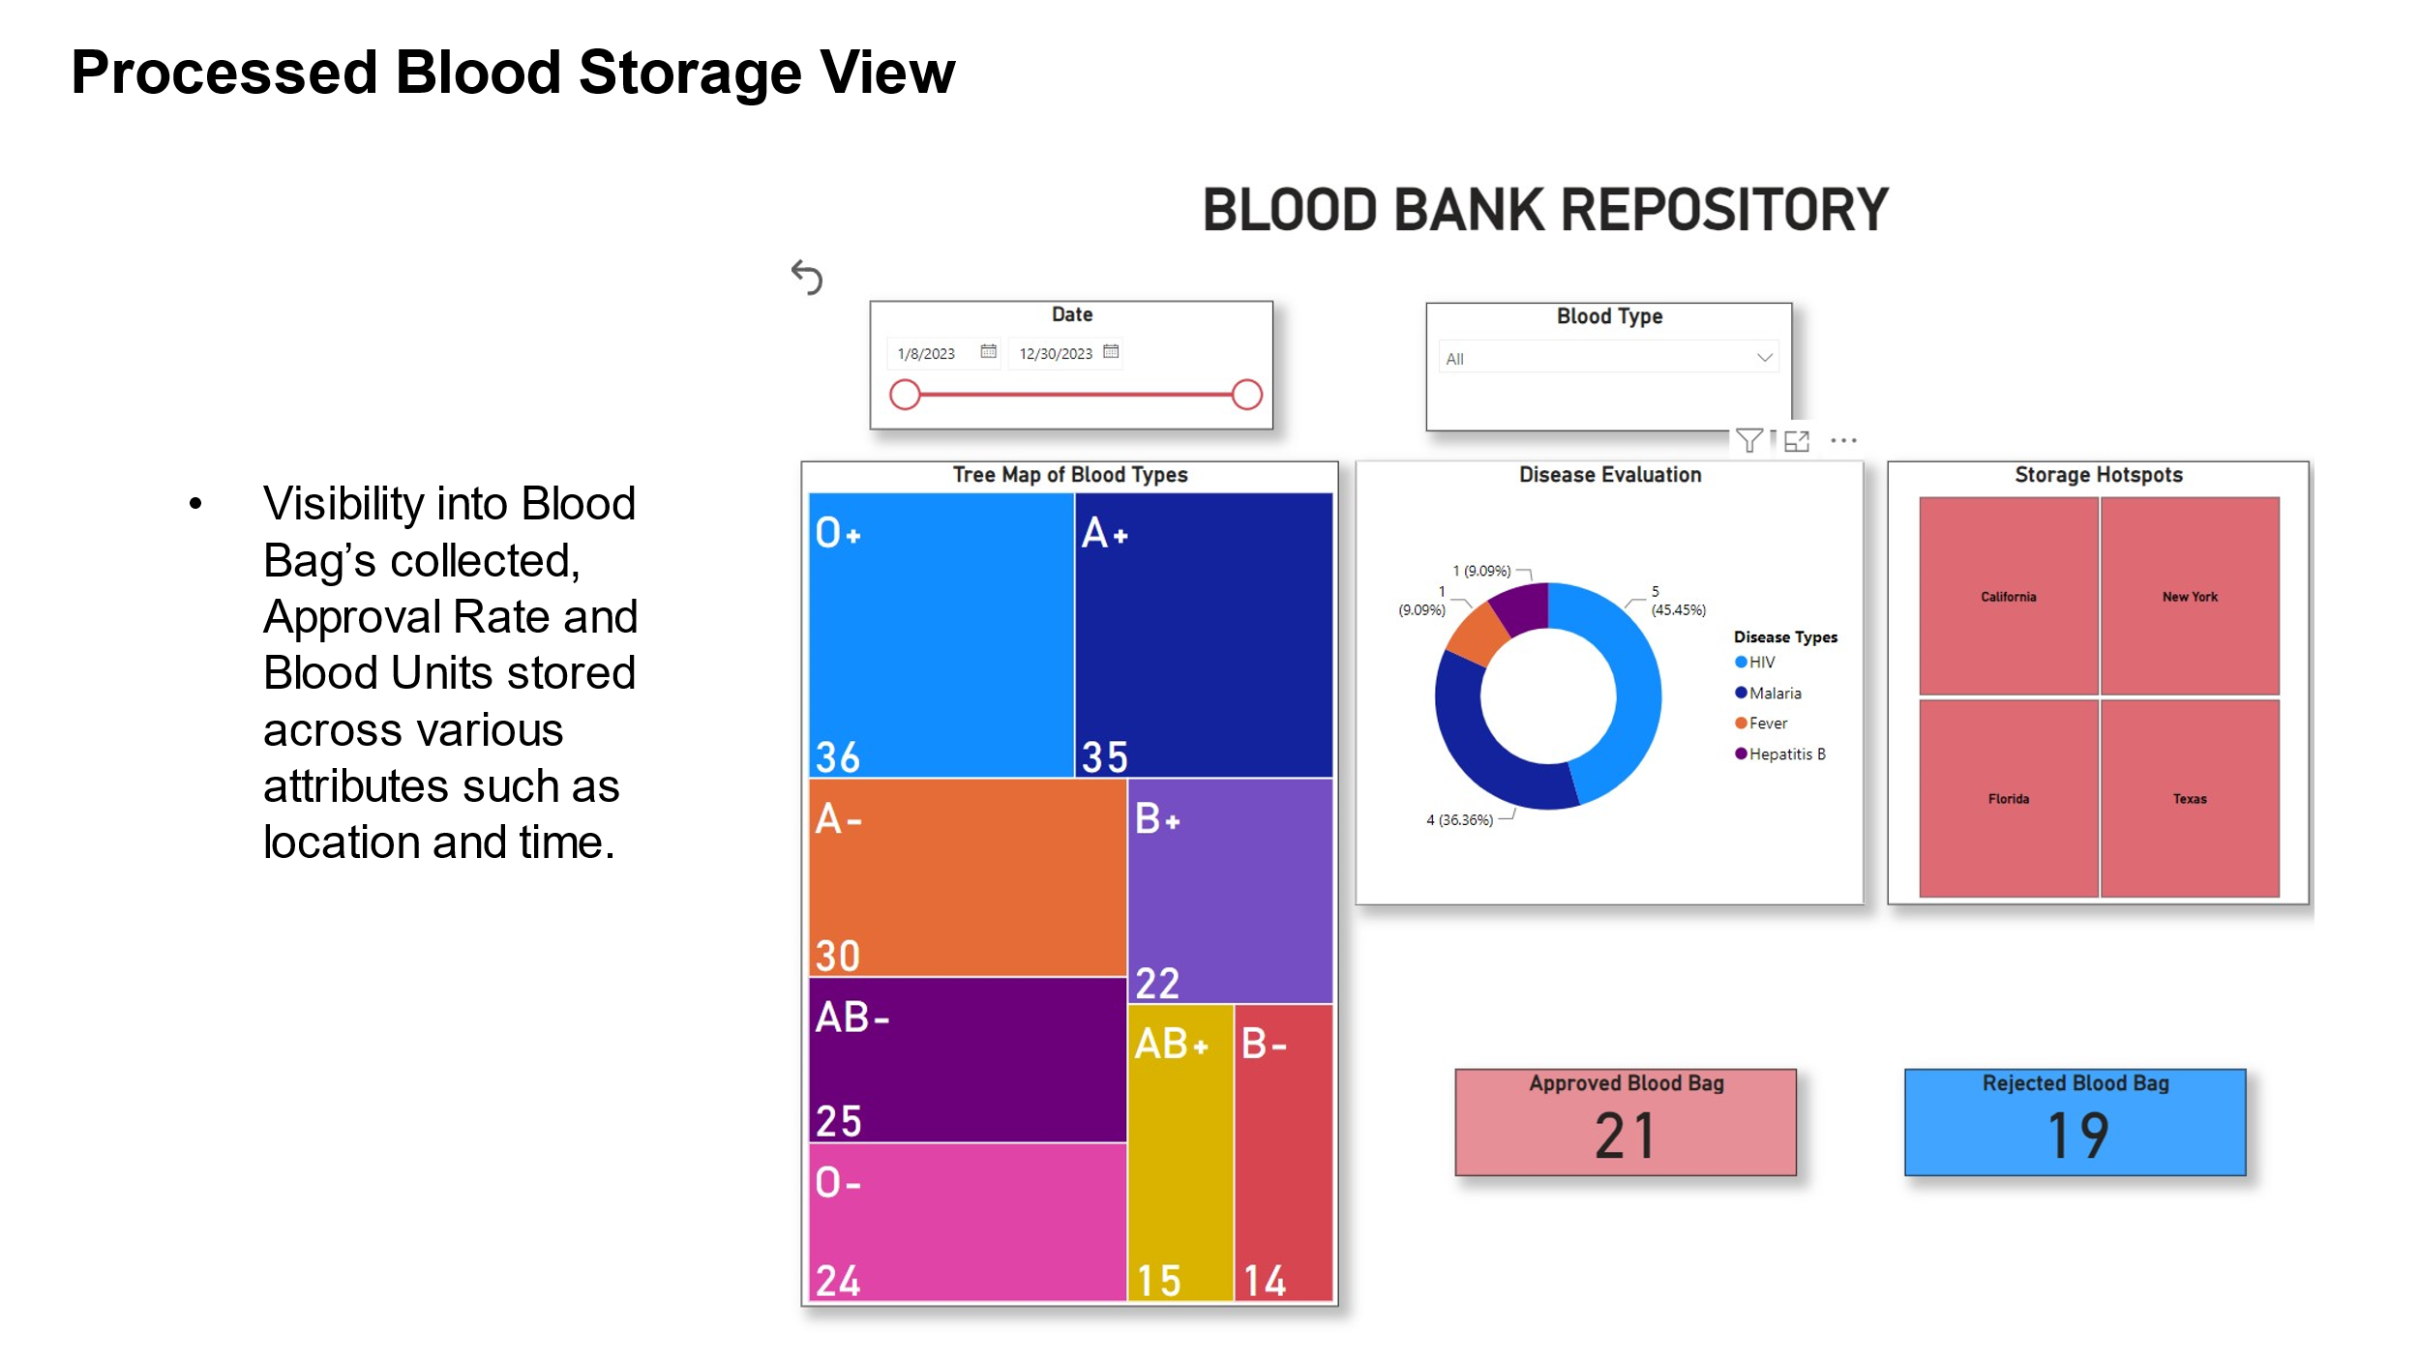

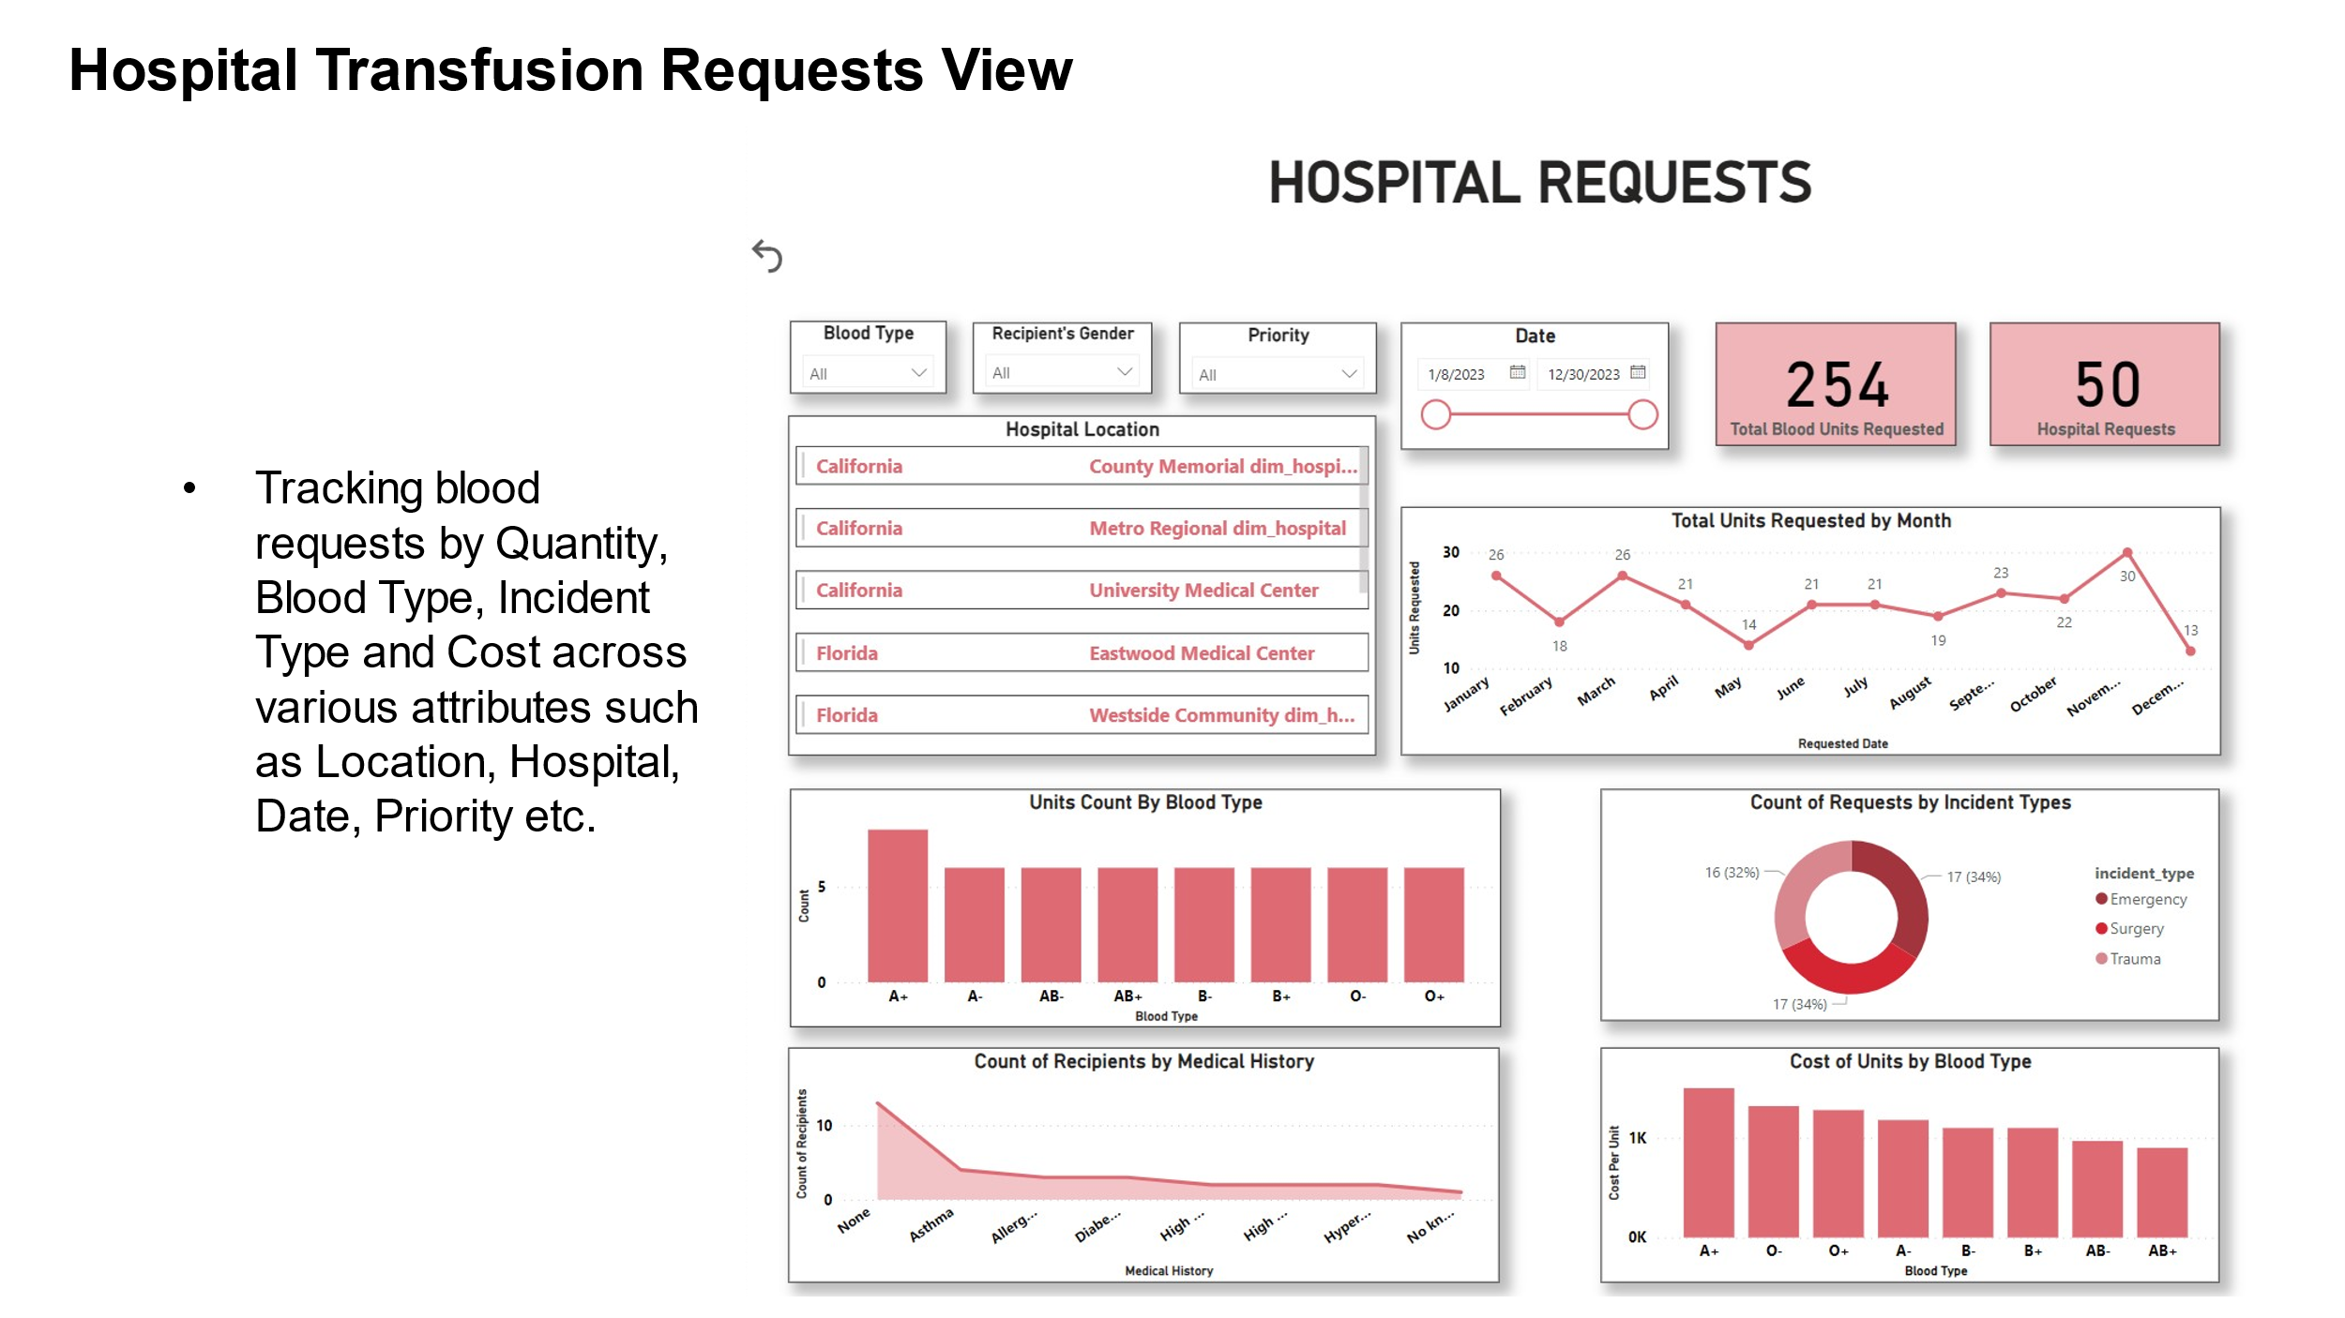

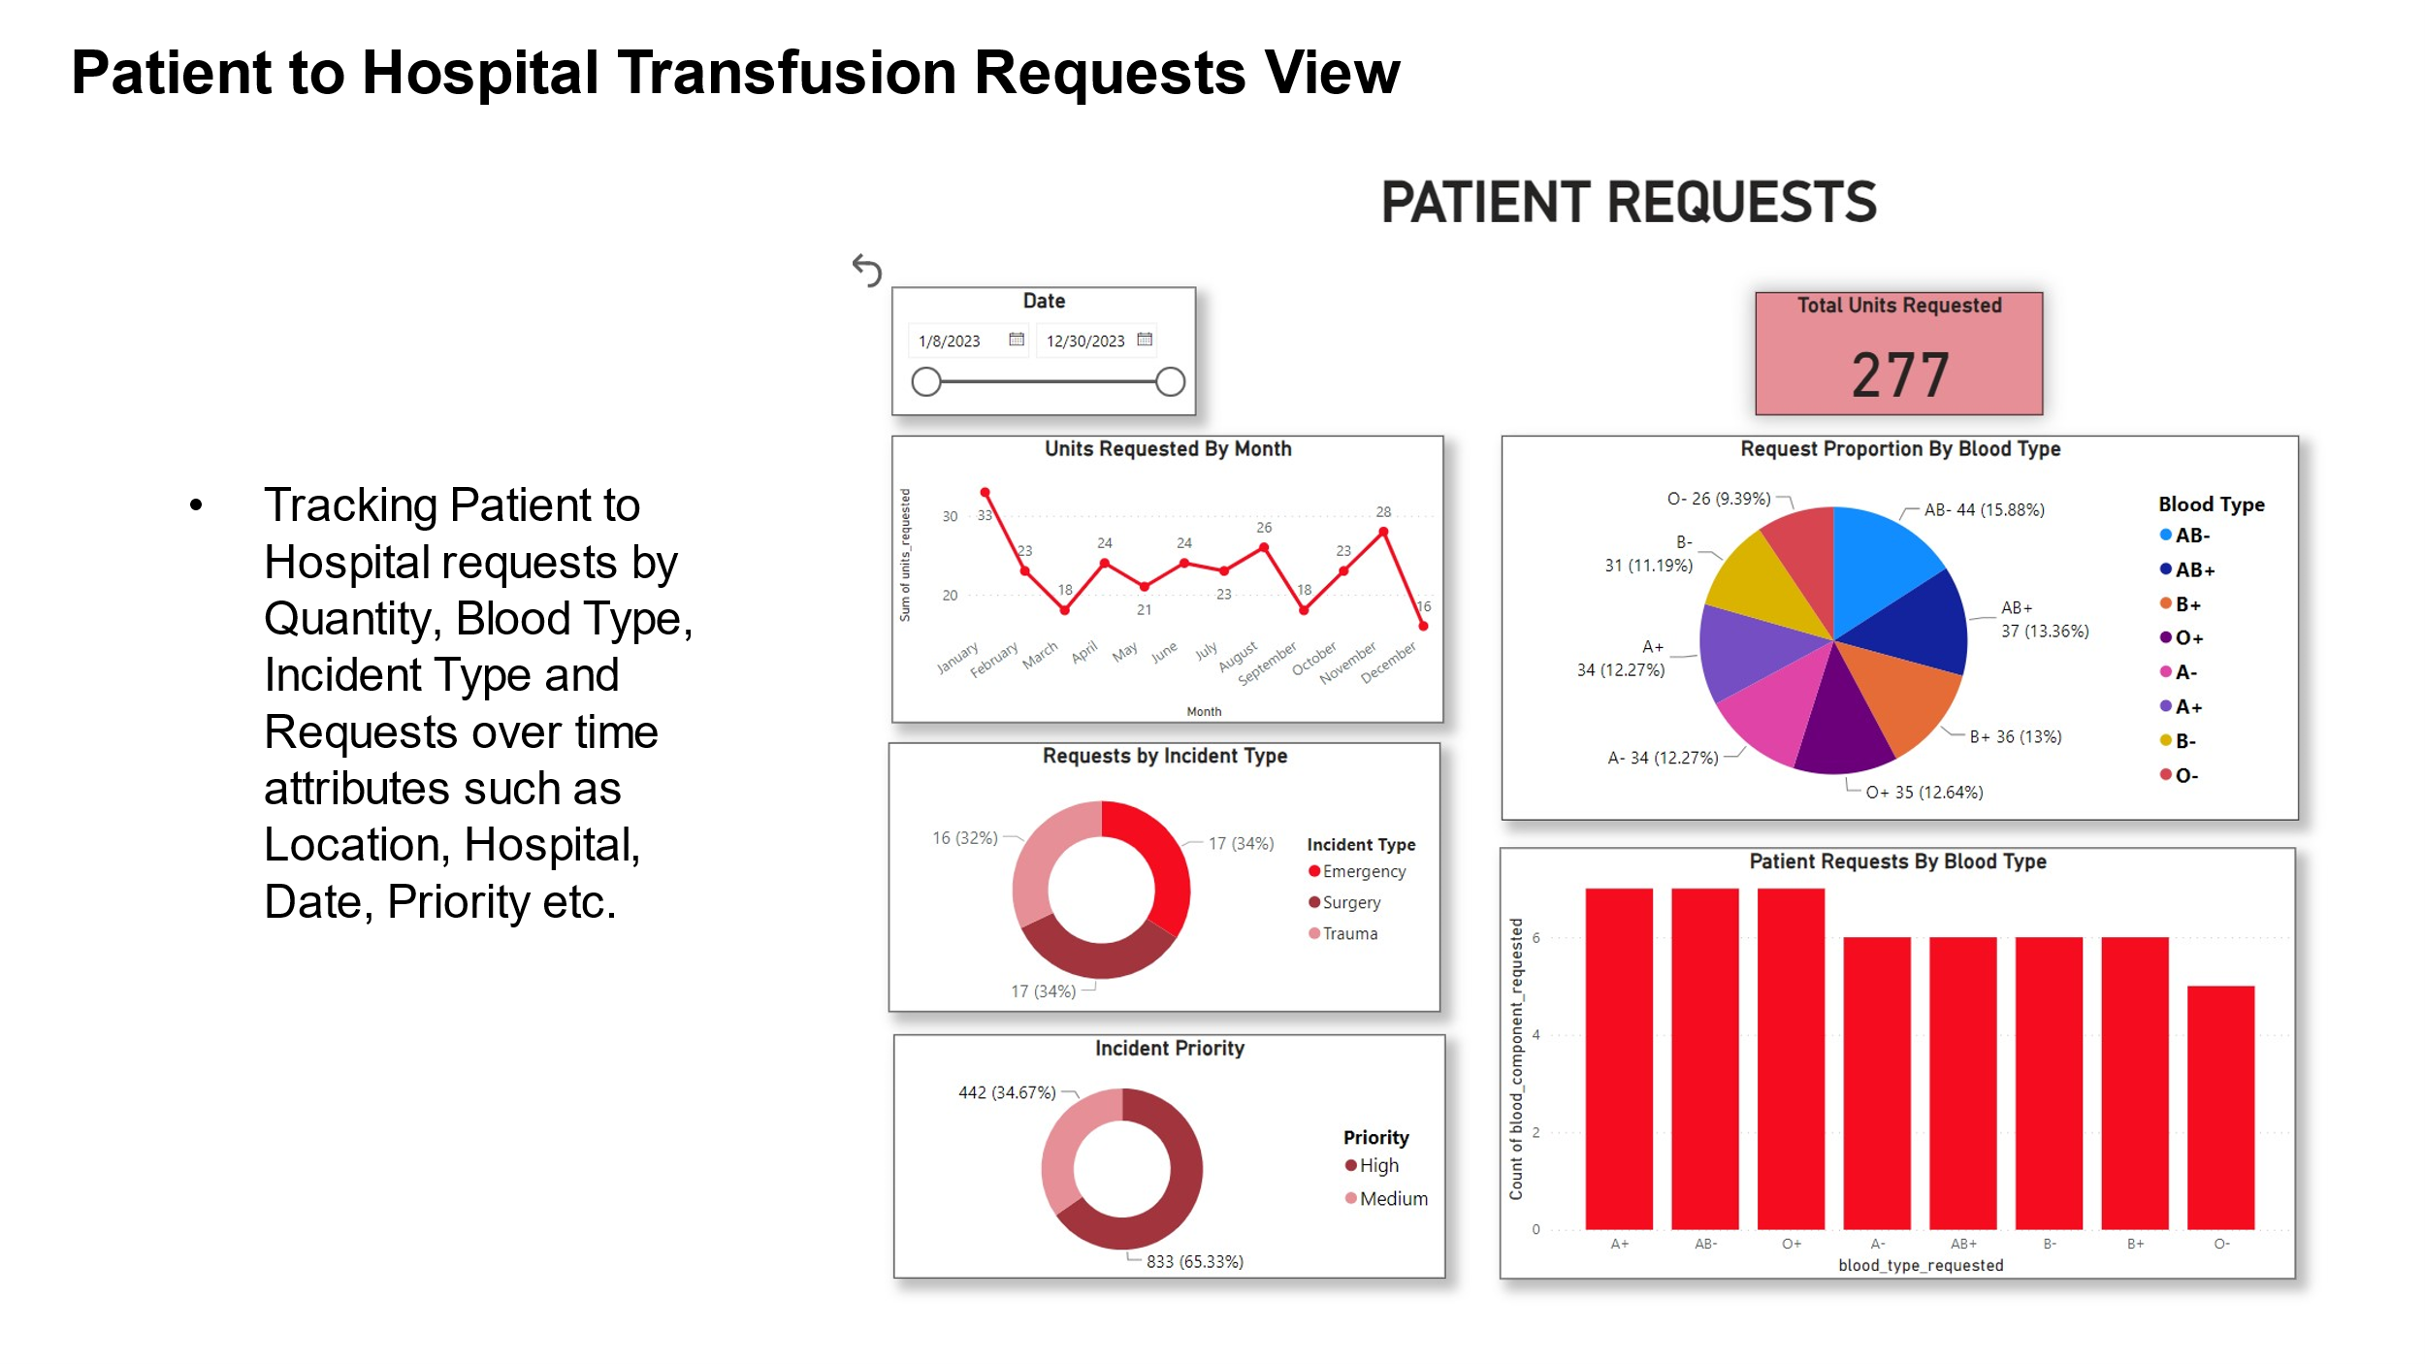

# 3.Team Log

REFERENCES

[1] <https://ieeexplore.ieee.org/abstract/document/6953176>

[2] <https://www.sciencedirect.com/science/article/pii/S187705092102500X>

[3] <https://ieeexplore.ieee.org/abstract/document/6953176>